5) What are the advantages and disadvantages of a very flexible (versus a less flexible) approach for regression or classification? Under what circumstances might a more flexible approach be preferred to a less flexible approach? When might a less flexible approach be preferred?

In less flexible approach we assume a model which gives a functional form of original function (f). Now we just estimate a set of parameters rather than estimating f. Disadvantage of this is that there is always a probability that the functional form used to estimate f is very different than true f, in which case the resulting estimate will be different from the data. This issue can be addressed by using more flexible approach where no assumptions regarding the functional form of f is made. Flexible approach considers all predictors from the data due to which they have more probability to accurately fit the original function. In general, fitting a more flexible model requires estimating a greater number of parameters. But as the model is too flexible, it can overfit the train data leading to large test error.

Less flexible approach can be used when we are interested in interference. When we want to understand how an individual predictor is associated with the response we use less flexible approach. However, when we are only interested in prediction and not the interpretability we use more flexible approach.

7) The table below provides a training data set containing six observations, three predictors, and one qualitative response variable.

|  |  |  |  |  |
| --- | --- | --- | --- | --- |
| Obs. | X1 | X2 | X3 | Y |
| 1 | 0 | 3 | 0 | Red |
| 2 | 2 | 0 | 0 | Red |
| 3 | 0 | 1 | 3 | Red |
| 4 | 0 | 1 | 2 | Green |
| 5 | -1 | 0 | 1 | Green |
| 6 | 1 | 1 | 1 | Red |

Suppose we wish to use this data set to make a prediction for *Y* when *X*1 = *X*2 = *X*3 = 0 using *K*-nearest neighbors.

1. Compute the Euclidean distance between each observation and the test point, *X*1 = *X*2 = *X*3 = 0.

Ans: Euclidean distance between each observation in training data and the test point is as follows:



(Note: Also computed in R as shown below and validated the R code results by above calculations)

R output:



1. What is our prediction with *K* = 1? Why?

R output:



The prediction is Green with K=1. For K=1 we pick 1 nearest neighbor of the test data set from the training data. The closest one is Green i.e. X1 = -1, X2 = 0, X3 = 1 from the training data set at 1.414214 and therefore the prediction was green

1. What is our prediction with *K* = 3? Why?

R output:

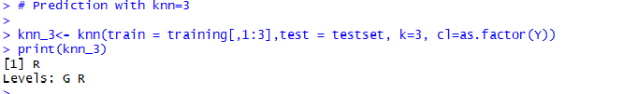

The prediction is Red with K=3. For K=1 we pick 3 nearest neighbors of the test data set from the training data predict on the bases of whichever color occurs most number of time. The 3 closest neighbors are as follows:

|  |  |  |  |  |
| --- | --- | --- | --- | --- |
| Y | X1 | X2 | X3 | Distance |
| Green | -1 | 0 | 1 | 1.414214 |
| Red | 1 | 1 | 1 | 1.732051 |
| Red | 2 | 0 | 0 | 2 |

As there are 2 Red’s and 1 Green the prediction was Red.

1. If the Bayes decision boundary in this problem is highly nonlinear, then would we expect the *best* value for *K* to be large or small? Why?

When K is small the decision boundary of K-n-n is more flexible but as K grows, the method becomes less flexible and produces a decision boundary that is close to linear. Now if the Bayes decision boundary is highly non-linear then we would need small K values. Whereas when the boundary becomes more rigid, we need large K values.

10. This exercise involves the Boston housing data set.

1. How many rows are in this data set? How many columns? What do the rows and columns represent?

Ans:

Number of rows: 506

Number of columns: 14

The data represents number of variables for 505 different records of housing values in suburbs of Boston. The variables are as follows:

|  |  |
| --- | --- |
| Column Names | Description |
| crim | per capita crime rate by town. |
| zn | proportion of residential land zoned for lots over 25,000 sq.ft. |
| indus | proportion of non-retail business acres per town. |
| chas | Charles River dummy variable (= 1 if tract bounds river; 0 otherwise). |
| nox | nitrogen oxides concentration (parts per 10 million). |
| rm | average number of rooms per dwelling. |
| age | proportion of owner-occupied units built prior to 1940. |
| dis | weighted mean of distances to five Boston employment centers. |
| rad | index of accessibility to radial highways. |
| tax | full-value property-tax rate per \$10,000. |
| ptratio | pupil-teacher ratio by town. |
| black | 1000(Bk - 0.63)^2 where *Bk* is the proportion of blacks by town. |
| lstat | lower status of the population (percent). |
| medv | median value of owner-occupied homes in \$1000s. |

1. Make some pairwise scatterplots of the predictors (columns) in this data set. Describe your findings

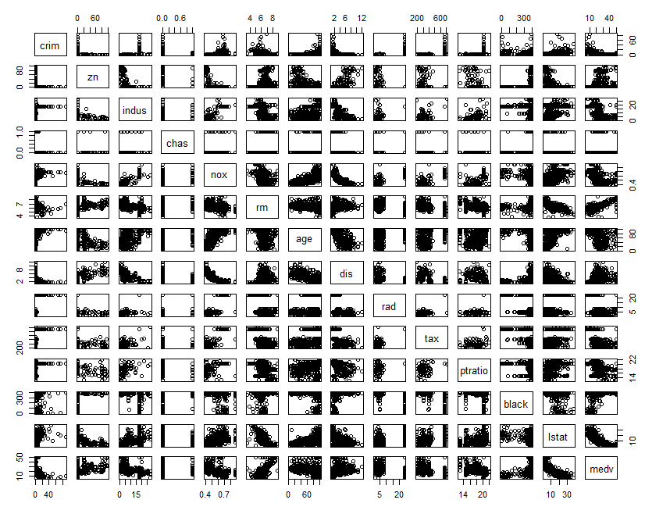

It is very difficult to understand the relation between all the columns when we plot all of them together so considering few of them together.

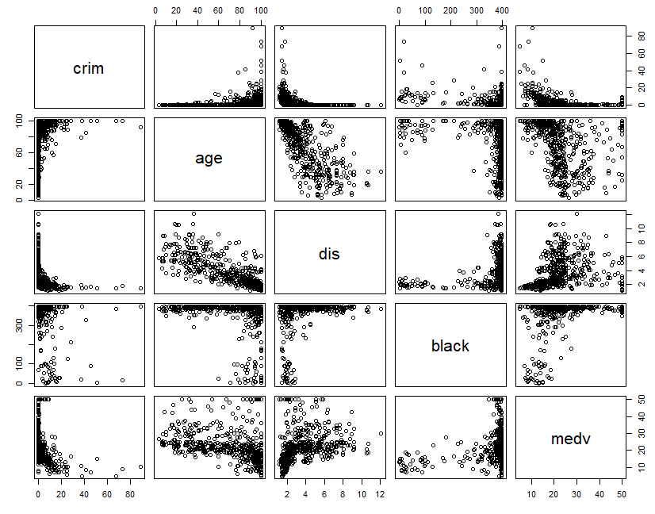

The scatterplot shows that the crime is more where there are older homes. Near the employment centers the crime is more and has more older houses. Crimes are less where the owner owned expensive houses.

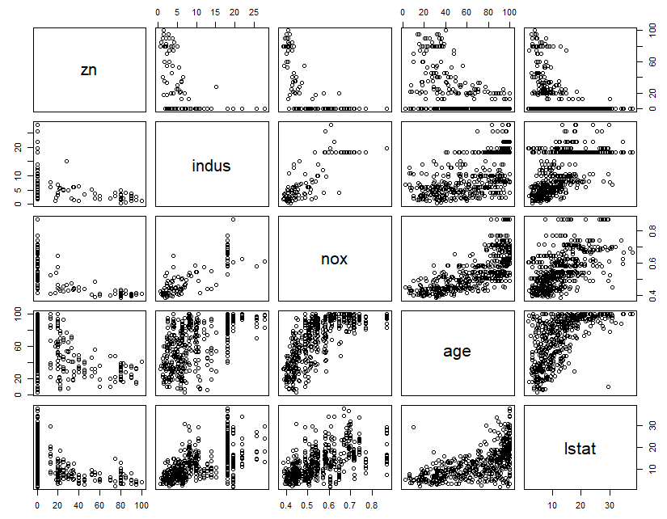

The proportion of residential land decreases as the proportional of non-residential business acres increases. Nitrogen oxide concentration is more in non-residential business acres and older houses. Percentage of lower status of population staying in residential area is more.

1. Are any of the predictors associated with per capita crime rate? If so, explain the relationship.

Ans: For the crime raate higher than 4, tax rates are higher (ranging from 403 – 666), 0.72% of the black proportion in town stays, lower status population is more and pupil-teacher ratio is high (range: 14.7 – 20.2). Also the plots show that near many older buildings more crimes are seen. Near the employment centers the crime is more and has more older houses. Crimes are less where the owner owned expensive houses.

R output:

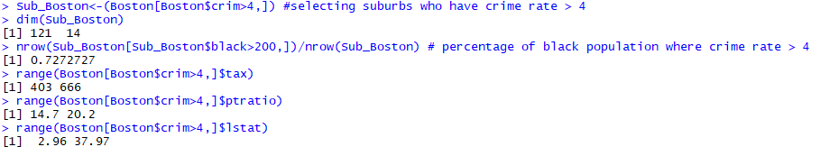

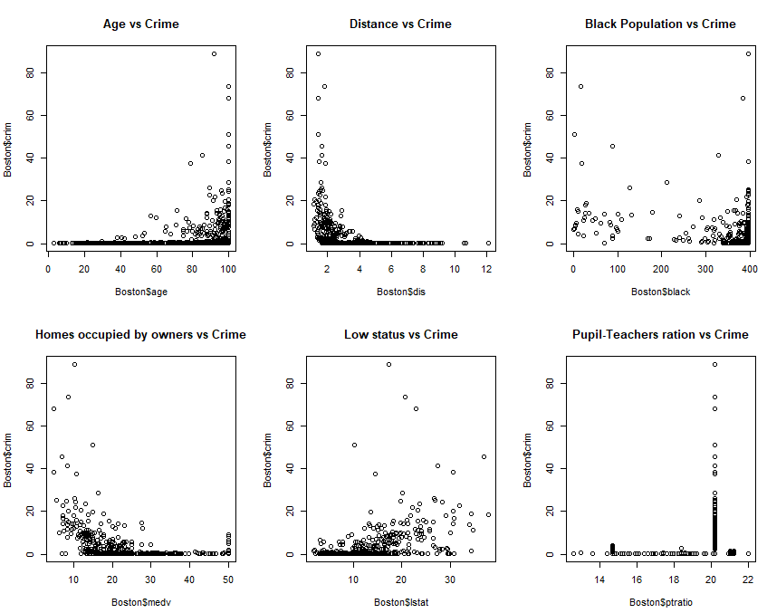

1. Do any of the suburbs of Boston appear to have particularly high crime rates? Tax rates? Pupil-teacher ratios? Comment on the range of each predictor.

Ans: The histogram of crime is right tailed which shows most cities have less crime rate, but 18 suburbs have crime rate more than 20. Only 18% of suburbs have crime rate more than 4. Tax rates are divide between suburbs with low rates but have a peak near 700 (Tax Rates Range: 187-711) and for crime rate greater than 20 the tax rates are 666. Histogram for Pupil- teacher ratio is left skewed and most of the suburbs have higher pupil-teacher ratio. For crime rate greater than 20 the pupil teacher ratio is 20.2.

R output:

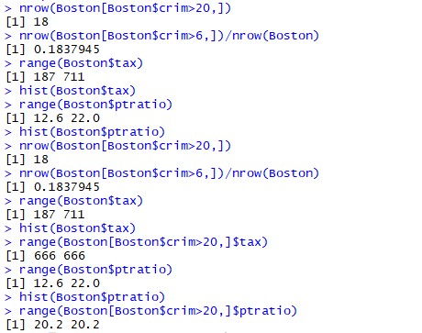

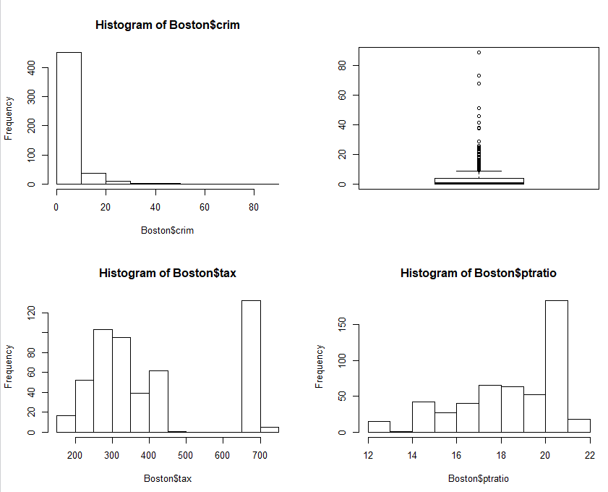

1. How many of the suburbs in this data set bound the Charles river?

Ans: 35 suburbs in data set bound to Charles river

R output:



1. What is the median pupil-teacher ratio among the towns in this data set?

Ans: The median pupil-teacher ratio = 19.05

R output:



1. Which suburb of Boston has lowest median value of owner occupied homes? What are the values of the other predictors for that suburb, and how do those values compare to the overall ranges for those predictors? Comment on your findings.

Ans: Suburbs that have following predictors have lowest value of owner occupied homes;

|  |  |  |
| --- | --- | --- |
| Columns | Range | Comments |
| crim | 38.3518-67.9208 | above 3rd quartile |
| zn | 0 | Least |
| indus | 18.1 | at 3rd quartile |
| chas | 0 | Not near the river |
| nox | 0.693 | above 3rd quartile |
| rm | 5.453-5.683 | below 1st quartile |
| age | 100 | Maximum |
| dis | 1.4896-1.4254 | below 1st quartile |
| rad | 24 | Maximum |
| tax | 666 | at 3rd quartile |
| ptratio | 20.2 | at 3rd quartile |
| black | 396.9-384.97 | above 1st quartile |
| lstat | 30.59-22.98 | above 3rd quartile |
| medv | 5 | Least |

R output: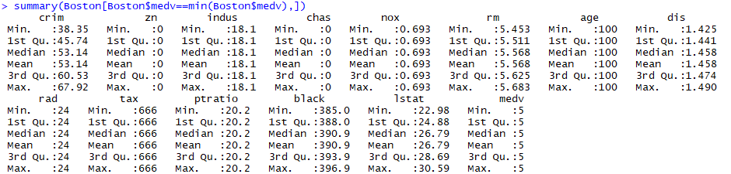

1. In this data set, how many of the suburbs average more than seven rooms per dwelling? More than eight rooms per dwelling? Comment on the suburbs that average more than eight rooms per dwelling.

Ans: 64 suburbs have average more than seven rooms per dwelling. 13 suburbs have average more than 8 rooms per dwelling. The Suburbs with average more than 8 rooms per dwelling have following predictors;

|  |  |  |
| --- | --- | --- |
| Columns | Range | Comments |
| crim | 0.02-3.47 | below 3rd quartile |
| zn | 0-95 | No effect |
| indus | 2-19.58 | below 3rd quartile |
| chas | 0-1 | not bounded by river |
| nox | 0.41-0.71 | above 1st quartile |
| rm | 8.03-8.78 | Maximum |
| age | 8.40-93.9 | Minimum |
| dis | 1.8 - 8.9 | No effect |
| rad | 2.0-24.0 | No effect |
| tax | 224-666 | above 1st quartile |
| ptratio | 13-20.2 | below 3rd quartile |
| black | 354.6-396.9 | above 1st quartile |
| lstat | 2.47-7.44 | below 1st quartile |
| medv | 21.9-50 | above 3rd quartile |

R output:

